Fitness Health Mobile Application

User Manual

Table of Contents

1.0 Download FH 3

1.1 Terms of Use 3

1.2 Getting Started 3

1.3 Initialization and first time running. 4

1.4 Create an account. 4

1.4.1 User Information 4

1.4.2 First Name 5

1.4.3 Last Name 5

1.4.4 User Type 6

1.4.5 Login ID 6

1.4.6 Password 6

1.4.7 Trainer 6

1.4.8 DOB 7

1.4.9 Email 7

1.4.10 Height 7

1.4.11 Weight 7

1.4.12 Address 7

1.4.13 Balance 8

1.5 Workout Information 8

1.5.1 Select Date 9

1.5.2 End Date 9

1.5.3 Frequency 9

1.5.4 Metric 10

1.5.5 Metric –Time 10

1.5.6 Metric -Repetition, 10

1.5.7 Metric – Distance 10

1.5.8 Description 10

1.6 Existing User 11

1.7 Trainer’s Page 12

1.8 User’s Page 13

2.0 Menus 15

2.0.1 Workout 15

2.0.2 User Info 16

2.0.3 About 17

2.0.4 Login 17

2.1 Detailed Operating 18

2.1.2 Top Screen icons 18

2.1.3 Bottom Screen icons 19

# 1.0 Download FH

# Terms of Use

The App is only for Demonstration purposes for CSC 505 Class.

The Developers holds no responsible for whatsoever.

# Getting Started

In Order to get started, you need to have Intel XDK along with a device which

runs Android 4.3.1 or above. If you do not have Intel XDK, download and install the Intel XDK from Intel’s Official website

<http://xdk-software.intel.com/>

You can get the FH mobile app from Github. <https://github.com/davenamin/FitnessHealth>

Click Clone to desktop.

After the File is downloaded,

Open the Intel XDK application and click on File, open and

Open the FitnessHealth application.

Now everything is ready, connect your android device with a USB to your computer.

In the Intel XDK, Click on Profile and Click Launch button.

# Initialization and first time running.

On your Mobile Device, you will see a new application named “ Intel App Preview”. Click on Intel App Preview and you are ready to use the app.

# 1.4 Create an account.

Every User or Trainer needs to create an account when they enter the app for the first time.

Click register, which will lead you to the User Information page.



## 1.4.1 User Information

The User Information page contains the list of information that a new user needs to enter for registering.

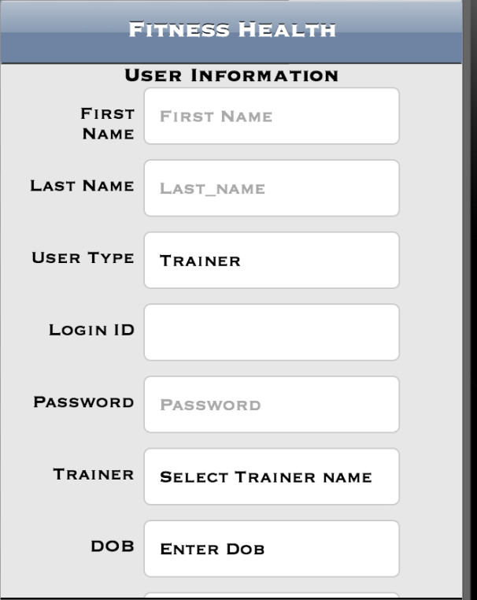

## 1.4.2 First Name

Enter your first name in the form.

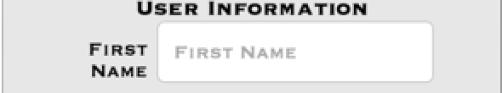

## 1.4.3 Last Name

Enter your Last name in the form.



## 1.4.4 User Type

Enter the User Type

Trainer: The trainer who can verify the user.

User: The User who will do the workouts.

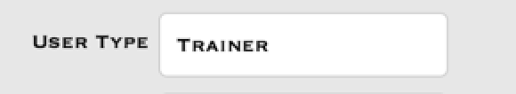

## 1.4.5 Login ID

Enter the Login ID.



## 1.4.6 Password

Enter the Password



## 1.4.7 Trainer

Select the Trainer name

A List of Trainers will appear.



## 1.4.8 DOB

Enter your Date of Birth



## 1.4.9 Email

Enter your Email ID.



## 1.4.10 Height

Enter your Height.



## 1.4.11 Weight

Enter your Weight.



## 1.4.12 Address

Enter your Address

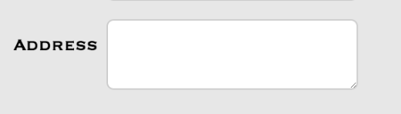

## 1.4.13 Balance

This will display the default balance for the user.



Click Submit after you finish all the above steps.

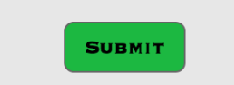

# 1.5 Workout Information

The Next Step is to enter the workout Information.

This will contain the workouts wants to do.

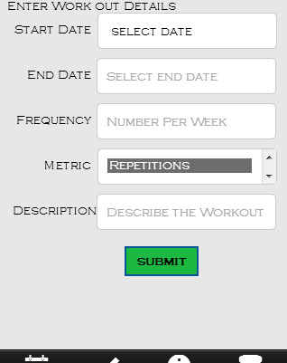

## 1.5.1 Select Date

Enter the start date for your workout.

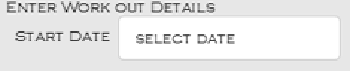

## 1.5.2 End Date

Enter your end date for your workout.

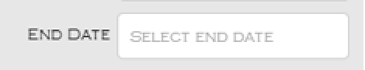

## 1.5.3 Frequency

Enter the frequency for your workout in numbers.

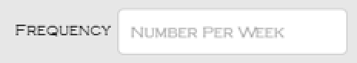

## 1.5.4 Metric

This will contain three different types of activities

## 1.5.5 Metric –Time

::Screenshots of FH:metric_time.png

This type of activity will calculate the time of workout.

## 1.5.6 Metric -Repetition,

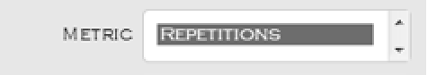

This type of activity will calculate the repetitions of workout.

## 1.5.7 Metric – Distance

This type of activity will calculate based on the distance.

::Screenshots of FH:metric_distance.png

## 1.5.8 Description

Enter the Description for your workout

# ::::Desktop:Screen Shot 2014-04-17 at 4.22.15 PM.png

# 1.6 Existing User

An Existing User can login into the system by entering the user name and password on the login screen

# ::Screenshots of FH:MainScreen.png

# 1.7 Trainer’s Page

After you login,

If you are a trainer, the trainer page will appear.

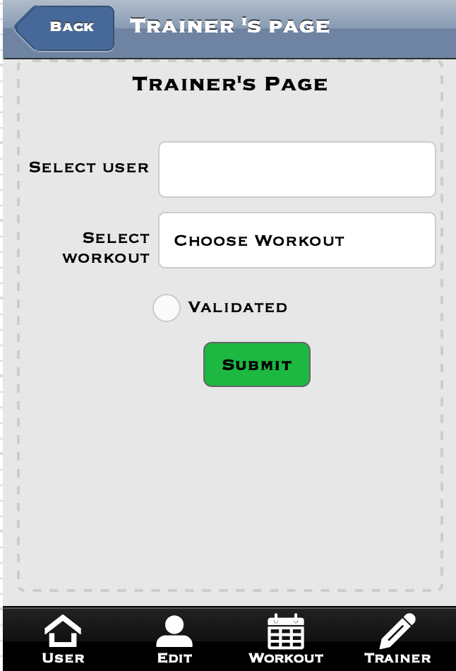

# 1.8 User’s Page

If you are a User, the user page will appear which will contain the list of your workout activities

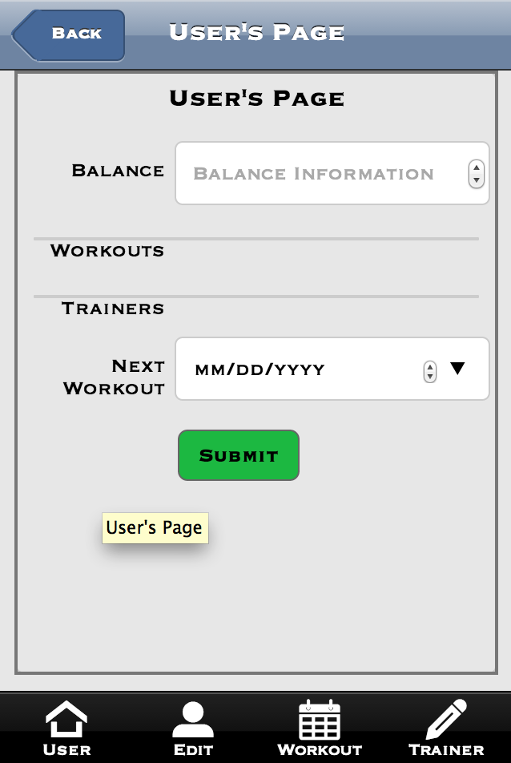

# 2.0 Menus

Simple Menu’s are used in the FH mobile App.

## 2.0.1 Workout

Clicking on the Workout menu will take the user to the workout page



The Workout Page will appear



## 2.0.2 User Info

User info menu will take the user to User info page.



The User info Menu takes to the User Information page



## 2.0.3 About

When you click on About menu, it will take you to the about Page



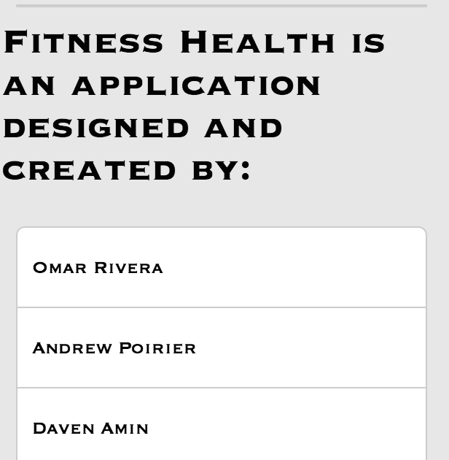

## 2.0.4 Login

The Login button will take you to the Login screen



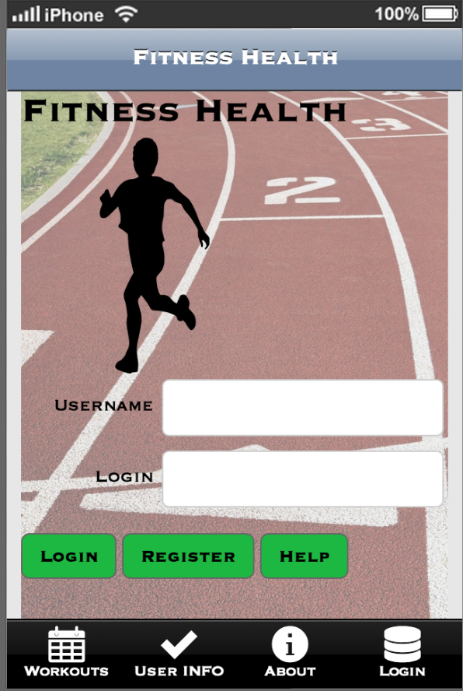

# 2.1 Detailed Operating

## 2.1.2 Top Screen icons

The Top Screen doesn’t have any icons except the title of the Application.

## 2.1.3 Bottom Screen icons

User –When the user clicks on this, User will contain the user information about the workouts.

Edit – When the user clicks on this, User can edit their information by using this.

Workout – The Workout will contain the workout information for each user.

Trainer – The Trainer icon will let the user to choose or change their trainer.

